Sri Lanka Institute of Information Technology



Assignment 2

Year 4, Semester 1 (2021)

Heart Attack Risk Prediction Using Random Forest Classifier

|  |  |  |
| --- | --- | --- |
| **Pathirana K.P.A.K.**  **IT18148046**  it18148046@my.sliit.lk | **Kariyapperuma.K.A.D.R.L.**  **IT18121766**  it18121766@my.sliit.lk | **Amarasinghe R.M.G.H**  **IT18172560**  it18172560@my.sliit.lk |

**Machine Learning - IT4060**

B.Sc. (Hons) in Information Technology Specialized in Software Engineering

**Table of Contents**

1. Introduction 1

1.1. Description 1

1.2. Problem Addressed 2

2. Data Collection 2

2.1. Dataset 2

2.2. Description of Attributes 3

3. Methodology 4

3.1. Machine learning algorithm selection 4

3.2. Random Forest 4

4. Implementation 5

4.1. Importing Libraries and packages 5

4.2. Reading the dataset 5

4.3. Data Preprocessing 6

4.4. Correlation 7

4.5. Distribution of Data 8

4.6. Process features and labels 9

4.7. Split the data into training and testing sets 9

4.8. Prediction Model 10

4.9. Accuracy score 10

4.10. Classification Report 10

4.11. Confusion matrix 11

4.12. Prediction result for new patient data 11

5. Critical analysis and Discussion 12

REFERENSES a

APENDIX b

Source code b

**List of Figures**

Figure 1 - Import Libraries and packages 5

Figure 2 - Read the dataset 5

Figure 3 - First five rows in the dataset 5

Figure 4 - Shape of the dataset 6

Figure 5 - Summary of statistics in dataset 6

Figure 6 - Check null values in dataset 6

Figure 7 - Check 0 values in dataset 6

Figure 8 - Check duplicate values 6

Figure 9 - Display duplicate values 7

Figure 10 - Delete duplicate values 7

Figure 11 - Shape of the dataset after data preprocessing 7

Figure 12 - Correlation in dataset 7

Figure 13 - Distribution of data 8

Figure 14 - Encode target labels 9

Figure 15 - Remove the labels from the features 9

Figure 16 - Labels in dataset 9

Figure 17 - Feature list 9

Figure 18 - Split the data into training and testing sets 9

Figure 19 - Shapes of train and test features and labels 10

Figure 20 - Instantiate and train the model 10

Figure 21 - Predict on the test data 10

Figure 22 - Accuracy score 10

Figure 23 - Classification report 10

Figure 24 - Confusion matrix 11

Figure 25 - Prediction result for new patient data 11

**List of Tables**

Table 1 - Description of Attributes 3

# **Introduction**

## **Description**

Studies have showed that heart disease is one of the major causes of death throughout the world. As it is a difficult task which demands expertise and higher knowledge for prediction it cannot be easily predicted by the medical specialists. Procedures such as bypass surgery and angioplasty can help blood and oxygen to flow more easily to the heart, but still the arteries will remain damaged, which means it is still more likely to have a heart attack. A computerized system in medical diagnosis would enhance medical efficiency and reduce costs in prevention from this disease. In this fast-moving world people want to live a very luxurious life and to live a comfortable life, therefore in this rat race people forget to take care of themselves, because of this the food habits change and entire lifestyle change. In this type of lifestyle, people are more tensed to have blood pressure, sugar at a very young age. As a result of all this small negligence it will lead to a major threat called heart attack.

Risk factors are conditions or habits that make a person more likely to develop a heart disease. They can also increase the probabilities that an existing disease will get worse. Important risk factors for heart diseases that can be controlled are high blood pressure, high blood cholesterol, physical inactivity, overweight, and diabetes. Recent research indicates that more than 95 percent of patients those who die from heart attacks have at least one of these general risk factors.

Much research has been conducted in attempt to pinpoint the most powerful factors of heart disease as well as accurately predict the overall risk. Heart Attack is even highlighted as a silent killer which leads to the death of the person without noticeable symptoms. Most of the heart patients are treated for the heart diseases but they are not well controlled. The early diagnosis of heart disease plays a vital role in making changes to lifestyle of high-risk patients and in turn to reduce the complications that occur. Overall system aims to calculate risk of future heart attack by analyzing data of heart patients which classifies whether they have the risk of a heart attack or not using machine-learning algorithms [1].

## **Problem Addressed**

Heart is a one of the most important organs of the human body. Over the last decade heart attack is the main reason for death in the world. The main reason for this is the busy lifestyle of the humans. Being very busy is avoiding good healthy habits of the humans. In Sri Lanka during the past 40 years, circulatory diseases including heart diseases and stroke have been the leading cause of death. It has increased from 3% in 1945 to 24% by 2018. According to the national representative study in Sri Lanka which has been conducted throughout the country has revealed that the mean age of heart disease victims was 58.2 years and highest number of heart patients were males (61.8%), because of smoking and excess of alcohol [2].

At the same time, several other medical conditions and life choices such as lack of exercise, high mental stress and fast-food habits can also put people at high risk for heart disease, including diabetes, overweight and obesity, unhealthy diet, and physical inactivity. Most of the patients are treated for the disease but the conditions have not been properly controlled, so there will be a risk of having it again. It is not possible to monitor patients every day in all cases correctly and consultation of a patient for 24 hours by a doctor is not available since it requires more wisdom, time, and expertise. Non-availability of medical diagnosing tools and medical experts specifically in undeveloped countries like Sri Lanka, diagnosis and cure of heart disease are very complex. So, a reasonable and accurate risk prediction of heart related diseases and guidance for keeping a healthy heart is necessary for a heart patient.

# **Data Collection**

## **Dataset**

The dataset required for this assignment was obtained from a **Kaggle** website. **Heart Attack Analysis & Prediction Dataset**was used for heart attack classification. It is the dataset at the top of most popular dataset in Kaggle. Dataset is containing CSV format (**heart.csv**). This data set is created by **Rashik Rahman**. This is a dataset related to the health care sector [4].

Dataset available here:

<https://www.kaggle.com/rashikrahmanpritom/heart-attack-analysis-prediction-dataset>

## **Description of Attributes**

The description of each attribute is mentioned below. Three hundred three (303) instances with fourteen attributes (14) having the shape of (303 * 14) [4].

|  |  |  |
| --- | --- | --- |
| **#** | **Feature** | **Description** |
| 1 | **age** | age in years |
| 2 | **sex** | sex  1 = male  0 = female |
| 3 | **cp** | chest pain type  Value 1: typical angina  Value 2: atypical angina  Value 3: non-anginal pain  Value 4: asymptomatic |
| 4 | **trtbps** | resting blood pressure (in mm Hg on admission to the hospital) |
| 5 | **chol** | serum cholestoral in mg/dl |
| 6 | **fbs** | (fasting blood sugar > 120 mg/dl)  1 = true  0 = false |
| 7 | **restecg** | resting electrocardiographic results  Value 0: normal  Value 1: having ST-T wave abnormality (T wave inversions  and/or ST elevation or depression of > 0.05 mV)  Value 2: showing probable or definite left ventricular  hypertrophy by Estes' criteria |
| 8 | **thalach** | maximum heart rate achieved |
| 9 | **exng** | exercise induced angina  1 = yes  0 = no |
| 10 | **oldpeak** | ST depression induced by exercise relative to rest |
| 11 | **slp** | the slope of the peak exercise ST segment  Value 1: upsloping  Value 2: flat  Value 3: downsloping |
| 12 | **caa** | number of major vessels (0-3) colored by flourosopy |
| 13 | **thall** | thal rate  normal =3  fixed defect =6  reversable defect = 7 |
| 14 | **output** | target variable  0 = No Heart Attack Risk  1 = Heart Attack Risk |

Table 1 - Description of Attributes

# **Methodology**

## **Machine learning algorithm selection**

To predict the presence of the heat attack, a classifier is needed to reduce the overfitting. So Random forest classification algorithm is suitable for that as it will obtain results from many decision trees. And Random forest can be used for regression problems and classification problems. This is binary classification problem, and those two classes are ***Heart Attack Risk***, ***No Heart Attack Risk***. Random forest classification can deal with the missing values. As it is very speedy it will provide a high accuracy for the classification problem [3].

## **Random Forest**

Random Forest is a supervised learning algorithm. In this algorithm most of the time train with the bagging method. Random forest makes many decision trees and merge them together to get the more accuracy prediction. Random forest is a flexible, easy to use that generates, even without hyper-parameter tuning, a great result most of the time. It is also one of the most used algorithms, because of its simplicity and diversity (it can be used for both classification and regression problems). In this project it explains how the random forest algorithm works, how it differs from other algorithms and how we use it. Form the attributes in the data set it will select the subset of the attributes randomly to split the node [5]. In Random forest it is easy to predict the matching attributes. One big advantage of random forest is that it can be used for both classification and regression problems, which form most current machine learning systems. classification is sometimes deemed the building block of machine learning.

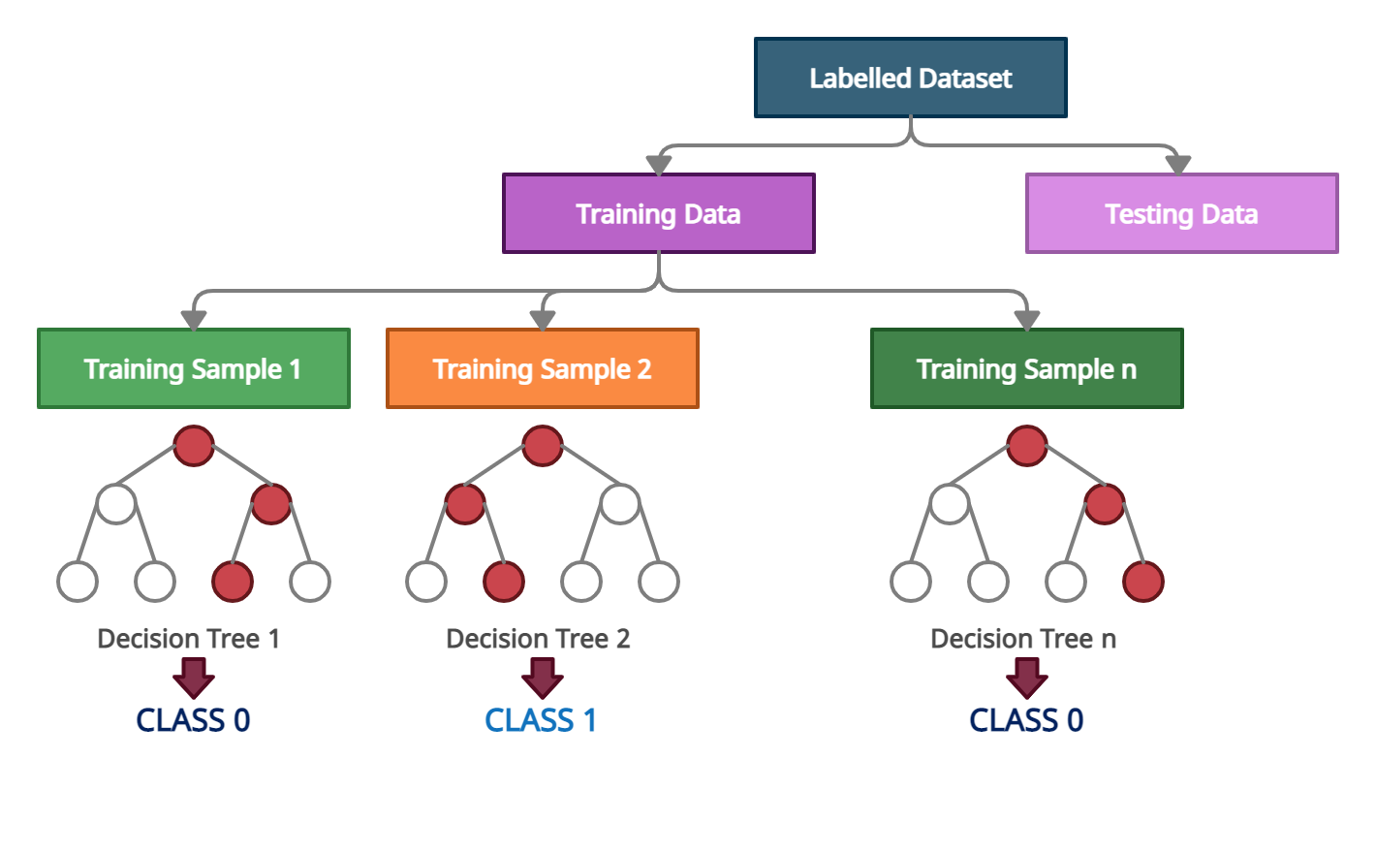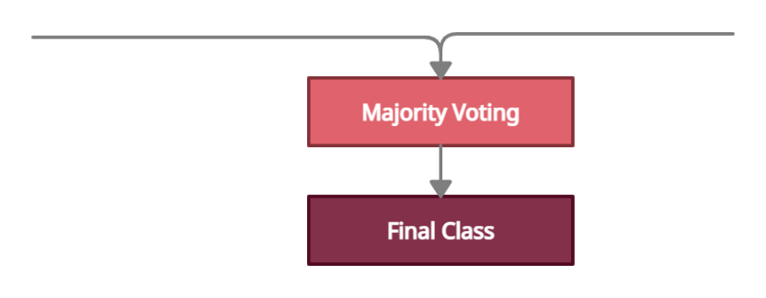

# **Implementation**

## **Importing Libraries and packages**

First, we need to import the required libraries and packages to implement the prediction model. Pandas is a package for data analysis and manipulation. Pandas help to explore, clean, and process datasets. Numpy is a library that utilized for working with arrays. Seaborn is data visualization library. It uses for drawing desirable and informative statistical graphs. Sklearn metrics use for measuring the quality of predictions. Matplotlib use for plotting data. LabelEncoder is package for encoding the levels of categorical features into numeric values. train_test_split is tool for split dataset into random train and test subsets. RandomForestClassifier is the machine learning model we use for this prediction.

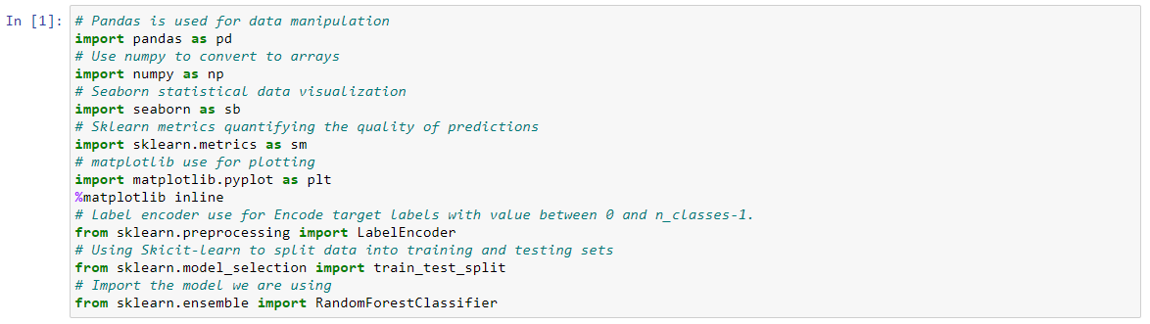

Figure 1 - Import Libraries and packages

## **Reading the dataset**

Heart Attack Analysis & Prediction Dataset is store in the heart.csv data source. Pandas library read_csv() method use for read the dataset. The read dataset was assigned to a variable called heart_dataset.



Figure 2 - Read the dataset

head() function used to get first 5 rows in dataset for quickly testing if right type of data in our dataset.

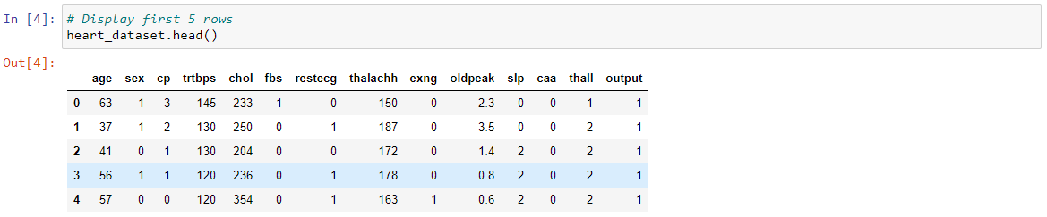

Figure 3 - First five rows in the dataset

shape() return the shape of our dataset. Our dataset contains 303 rows and 14 columns.



Figure 4 - Shape of the dataset

describe() function use for get summary of statistics in our dataset. It gives count, mean, standard deviation(std), and IQR values.

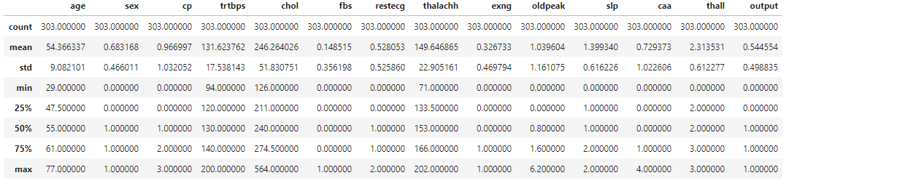

Figure 5 - Summary of statistics in dataset

## **Data Preprocessing**

Data preprocessing is a very important step. Real-world datasets mostly contain missing values, noises, and maybe in an unusable format. We check null values in our dataset. There are no null values in our heart dataset.



Figure 6 - Check null values in dataset

In our dataset cannot have 0 for age, trtbps, chol, thalachh columns. There are no 0 values in that columns.

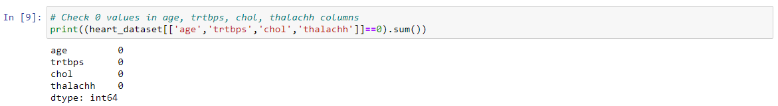

Figure 7 - Check 0 values in dataset

Our dataset has only one duplicate record. We delete that record to increase the accuracy of prediction.



Figure 8 - Check duplicate values

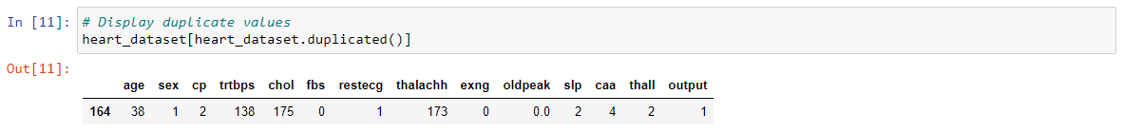

Figure 9 - Display duplicate values



Figure 10 - Delete duplicate values

After deleting that record, a dataset contains 302 rows and 14 columns.



Figure 11 - Shape of the dataset after data preprocessing

## **Correlation**

This table visualize correlation coefficients between variables. corr() method use for get correlation in our dataset.

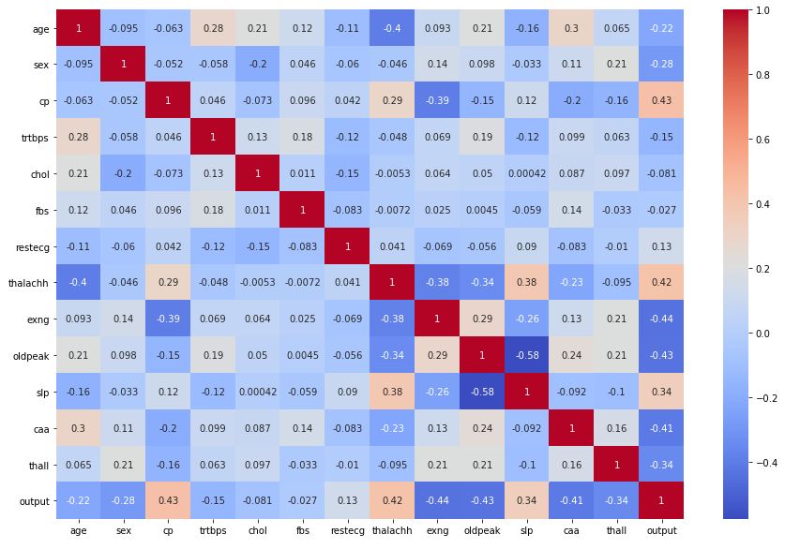

Figure 12 - Correlation in dataset

## **Distribution of Data**

These histograms visualize distribution of our dataset.

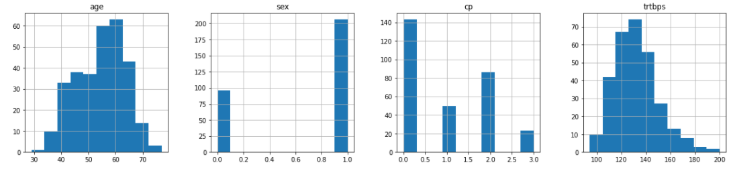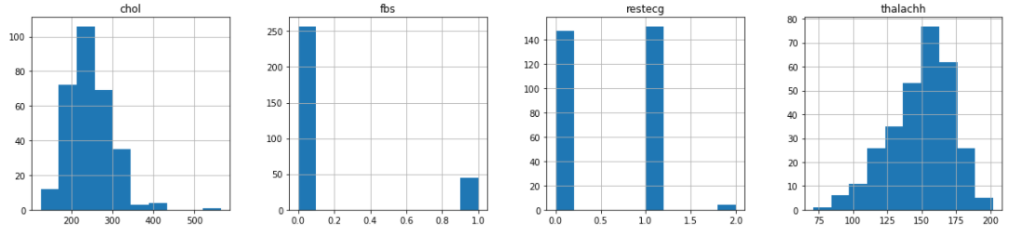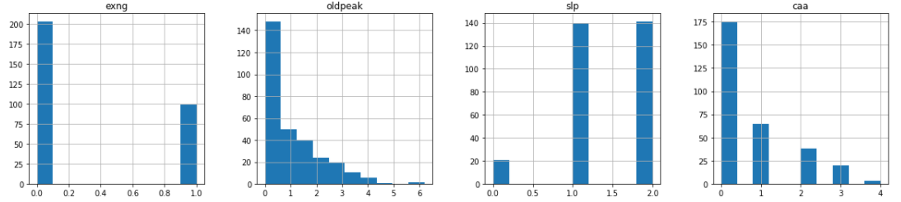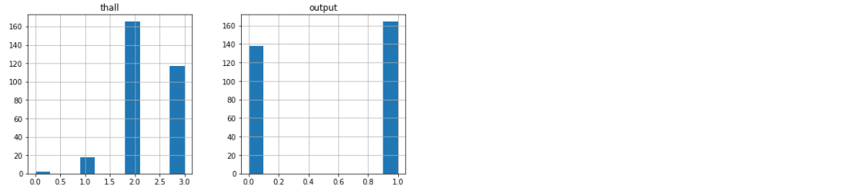

Figure 13 - Distribution of data

## **Process features and labels**

We use LabelEncoder() for encoding the levels of categorical features into numeric values and It Encode target labels with value between 0 and n_classes-1.

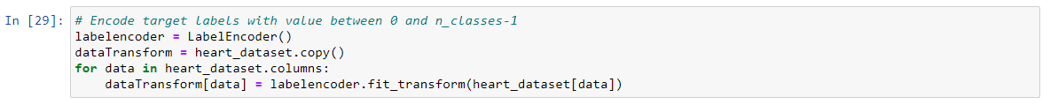

Figure 14 - Encode target labels

We remove labels and assign features data to X variable.



Figure 15 - Remove the labels from the features

Assign labels values to Y variable.



Figure 16 - Labels in dataset

Save feature names for later use.

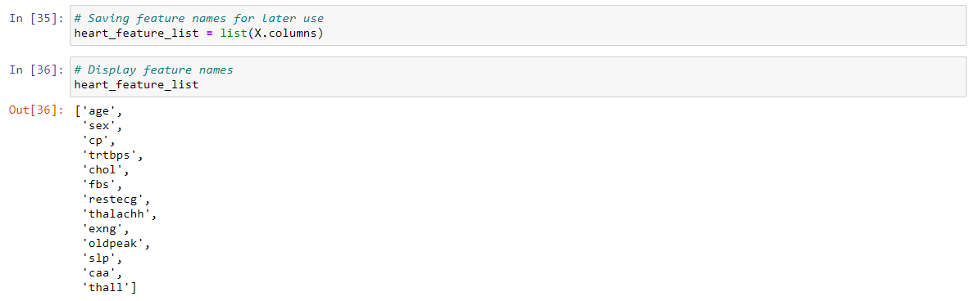

Figure 17 - Feature list

## **Split the data into training and testing sets**

Sklearn train_test_split tool split dataset into random train and test subsets. We use 0.2 test size for proportion of the dataset to include in the test split. We use 80 as a random_state and it Controls the shuffling applied to the data before applying the split. We use default values for train_size, shuffle, stratify parameters.



Figure 18 - Split the data into training and testing sets

Now our dataset splite 2 subsets as a train and test. Train subset contain 241 rows. Test subset contain 61 rows. X_train is training feature subset. Y_train is a labels use for testing model. X_test is feature subset use for test model. Y_test is labels for test model.

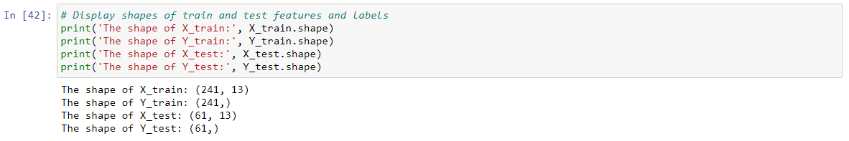

Figure 19 - Shapes of train and test features and labels

## **Prediction Model**

Instantiate model with 1200 decision trees. Then train our model using training dataset.

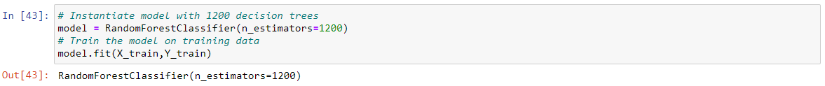

Figure 20 - Instantiate and train the model

we get prediction result for test features subset.



Figure 21 - Predict on the test data

## **Accuracy score**

Sklearn metrics accuracy_score use for computes accuracy of prediction model. This prediction model has 0.8688524590163934 accuracy. If ${\hat{y}}_{i}$ is the predicted value of the $ⅈ$-th sample and $y_{i}$ is the corresponding true value, then the fraction of correct predictions over $n_{samples}$ is defined as [6],



$accuracy\left(y,\hat{y}\right)=\frac{1}{n_{samples}}\sum_{i=0}^{n_{samples}-1}{1}\left({\hat{y}}_{i}=y_{i}\right)$

Figure 22 - Accuracy score

## **Classification Report**

Classification report is a text report indicating the main classification metrics. this function use to calculate precision, recall, f1-score, and accuracy. According to our classification report Heart Attack Risk in the testing data set there were 21 data observation and 40 observations labeled as 1. (21 + 40 = 61) Testting data set have total 61 rows according to figure 19.

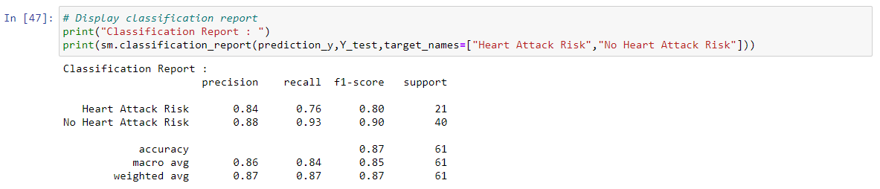

Figure 23 - Classification report

## **Confusion matrix**

Compute confusion matrix to evaluate the accuracy of a classification by computing the confusion matrix with each row corresponding to the true class. confusing matrix is basically use for double check what are the actual class labels of the testing data set and what was the predicted labels of the testing data set, then we are going to create a matrix it shows what are the correctly classified observations and how much as mis classified. In X axis have true labels and Y axis have predicted values. when the true labels are 0 it has correctly classified them as 0 in 16 observations. Only 3 observations predict true class 0 as 1. likewise, when the true label is 1 it has correctly classified 37 times but one time it is identify the label as 0 in 5 times.

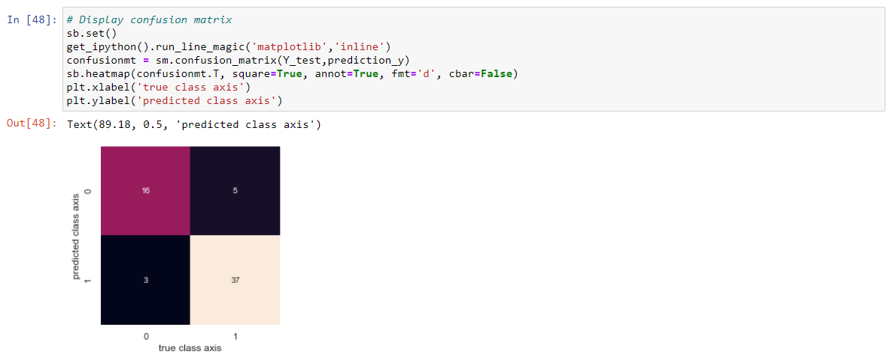

Figure 24 - Confusion matrix

## **Prediction result for new patient data**

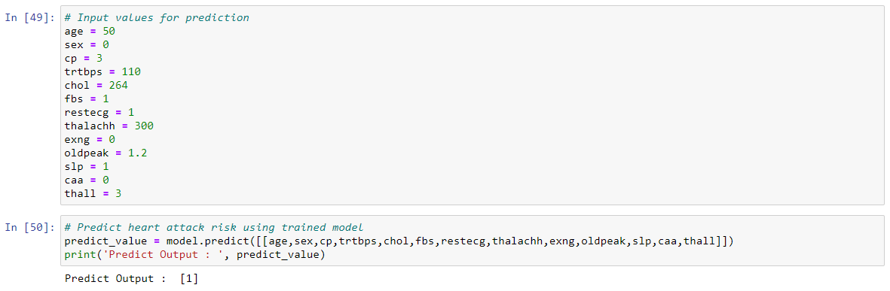Finally, we predict heart attack risk for new input values using our trained prediction model.

Figure 25 - Prediction result for new patient data

# **Critical analysis and Discussion**

This application is very useful for hospitals. This application can easily predict the risk of heart attack in patients coming to the hospitals. This application helps a person to diagnose and treat a heart attack at an early stage before it occurs.

For future improvements we can suggest increasing the accuracy of the application by increasing the number of features and to make this application applicable for heart patients to detect their heart attack risk. We can also increase the number of category levels of the heart attack risk status to improve the application. Also, can suggest a heart attack risk status providing them in which stage they are and can predict the heart attack risk and give them proper guidance on meals, exercises according to the heart attack risk.

For furthermore development by using IOT technologies, can create a wearable device like watch to identify the real time patient’s data and can train a model with those data to predict the heart attack risk. Also, it is better to alert the patient using the smart device wherever possible before a high-risk situation. A mobile app associated with the device can make it even easier. If further improved, we can connect the device to the hospital system and let the hospital doctor know before the patient has a heart attack. Then your personal doctor can prepare the necessary treatment before you have a heart attack. The doctor will then take you to your current location and take you to the hospital in an ambulance before you have a heart attack. Then when that person has a heart attack, his life risk is reduced because he is with the doctor.



# **REFERENSES**

[1] Nichenametla, Rajesh & Maneesha, T. & Hafeez, Shaik & Krishna, Hari. (2018). “Prediction of Heart Disease Using Machine Learning Algorithms”. International Journal of Engineering and Technology (UAE). 7. 363-366. 10.14419/ijet.v7i2.32.15714.

[2] (IJACSA) International Journal of Advanced Computer Science and Applications, Vol. 10, No. 12, 2019 25 8 |” Cardiovascular Disease Diagnosis: A Machine Learning Interpretation Approach”Hossam Meshref Associate Professor, Computer Science Department College of Computers and Information Technology Taif University, Taif, Saudi Arabia

[3] “Prediction of Heart Disease by Clustering and Classification Techniques” Reetu Singh1, E. Rajesh2 1 Department of Computing Science and Engineering, Galgotias University, Greater Noida, India 2 Department of Computing Science and Engineering, Galgotias University, Greater Noida. Accepted: 16/May/2019, Published: 31/May/2019.

[4] Heart Attack Analysis & Prediction Dataset. [Online]. Available: https://www.kaggle.com/rashikrahmanpritom/heart-attack-analysis-prediction-dataset [Accessed: 02-April-2021].

[5] sklearn.ensemble.RandomForestClassifier. [Online]. Available: https://scikit-learn.org/stable/modules/generated/sklearn.ensemble.RandomForestClassifier.html [Accessed: 10- April -2021].

[6] Metrics and scoring: quantifying the quality of predictions. [Online]. Available: https://scikit-learn.org/stable/modules/model_evaluation.html#accuracy-score [Accessed: 10- April -2021].

# **APENDIX**

## **Source code**

----------------------------------------------------------------------------------------------------------------

*# Pandas is used for data manipulation*

**import** pandas **as** pd

*# Use numpy to convert to arrays*

**import** numpy **as** np

*# Seaborn statistical data visualization*

**import** seaborn **as** sb

*# Sklearn metrics quantifying the quality of predictions*

**import** sklearn.metrics **as** sm

*# matplotlib use for plotting*

**import** matplotlib.pyplot **as** plt

**%matplotlib** inline

*# Label encoder use for Encode target labels with value between 0 and n_classes-1.*

**from** sklearn.preprocessing **import** LabelEncoder

*# Using Skicit-learn to split data into training and testing sets*

**from** sklearn.model_selection **import** train_test_split

*# Import the model we are using*

**from** sklearn.ensemble **import** RandomForestClassifier

----------------------------------------------------------------------------------------------------------------

*# Read in dataset*

heart_dataset **=** pd**.**read_csv('heart.csv')

----------------------------------------------------------------------------------------------------------------

*# Display dataset*

heart_dataset

----------------------------------------------------------------------------------------------------------------

*# Display first 5 rows*

heart_dataset**.**head()

----------------------------------------------------------------------------------------------------------------

*# Shape of the dataset*

heart_dataset**.**shape

----------------------------------------------------------------------------------------------------------------

*# Columns of the dataset*

heart_dataset**.**columns

----------------------------------------------------------------------------------------------------------------

*# Descriptive statistics for each column*

heart_dataset**.**describe()

----------------------------------------------------------------------------------------------------------------

*# Check null values*

sum(heart_dataset**.**isnull()**.**sum())

----------------------------------------------------------------------------------------------------------------

*# Check 0 values in age, trtbps, chol, thalachh columns*

print((heart_dataset[['age','trtbps','chol','thalachh']]**==**0)**.**sum())

----------------------------------------------------------------------------------------------------------------

*# Check duplicate values*

heart_dataset**.**duplicated()**.**sum()

----------------------------------------------------------------------------------------------------------------

*# Display duplicate values*

heart_dataset[heart_dataset**.**duplicated()]

----------------------------------------------------------------------------------------------------------------

*# Delete duplicate values*

heart_dataset**.**drop_duplicates(inplace**=True**)

----------------------------------------------------------------------------------------------------------------

*# Shape of the dataset after data pre processing*

heart_dataset**.**shape

----------------------------------------------------------------------------------------------------------------

*# Display correlation coefficients between variables*

plt**.**figure(figsize**=**(15,10))

sb**.**heatmap(heart_dataset**.**corr(),annot**=True**,cmap**=**'coolwarm')

----------------------------------------------------------------------------------------------------------------

*# Display distribution of data*

heart_dataset**.**hist(figsize**=**(20,20))

plt**.**show()

----------------------------------------------------------------------------------------------------------------

*# Plot prevalence of heart attack by cp*

sb**.**countplot(data**=**heart_dataset,hue**=**heart_dataset['output'],x**=**heart_dataset['cp'], palette**=**"mako")

plt**.**title('Prevalence of Heart attack by cp',fontsize**=**15)

----------------------------------------------------------------------------------------------------------------

*# Plot prevalence of heart attack by age*

plt**.**figure(figsize **=** (20, 8))

sb**.**countplot(data**=**heart_dataset,hue**=**heart_dataset['output'],x**=**heart_dataset['age'], palette**=**"mako")

plt**.**title('Prevalence of Heart attack by age',fontsize**=**15)

----------------------------------------------------------------------------------------------------------------

*# Plot prevalence of heart attack by sex*

sb**.**countplot(data**=**heart_dataset,hue**=**heart_dataset['output'],x**=**heart_dataset['sex'], palette**=**"mako")

plt**.**title('Prevalence of Heart attack by Sex',fontsize**=**15)

----------------------------------------------------------------------------------------------------------------

*# Plot prevalence of heart attack by trtbps*

plt**.**figure(figsize **=** (20, 8))

sb**.**countplot(data**=**heart_dataset,hue**=**heart_dataset['output'],x**=**heart_dataset['trtbps'], palette**=**"mako")

plt**.**title('Prevalence of Heart attack by trtbps',fontsize**=**15)

----------------------------------------------------------------------------------------------------------------

*# Plot prevalence of heart attack by fasting blood sugar > 120 mg/dl*

sb**.**countplot(data**=**heart_dataset,hue**=**heart_dataset['output'],x**=**heart_dataset['fbs'], palette**=**"mako")

plt**.**title('Prevalence of Heart attack by fasting blood sugar > 120 mg/dl',fontsize**=**15)

----------------------------------------------------------------------------------------------------------------

*# Plot prevalence of heart attack by restecg*

sb**.**countplot(data**=**heart_dataset,hue**=**heart_dataset['output'],x**=**heart_dataset['restecg'], palette**=**"mako")

plt**.**title('Prevalence of Heart attack by restecg',fontsize**=**15)

----------------------------------------------------------------------------------------------------------------

*# Plot prevalence of heart attack by exercise induced angina*

sb**.**countplot(data**=**heart_dataset,hue**=**heart_dataset['output'],x**=**heart_dataset['exng'], palette**=**"mako")

plt**.**title('Prevalence of Heart attack by Exercise induced angina',fontsize**=**15)

----------------------------------------------------------------------------------------------------------------

*# Plot prevalence of heart attack by oldpeak*

plt**.**figure(figsize **=** (20, 8))

sb**.**countplot(data**=**heart_dataset,hue**=**heart_dataset['output'],x**=**heart_dataset['oldpeak'], palette**=**"mako")

plt**.**title('Prevalence of Heart attack by oldpeak',fontsize**=**15)

----------------------------------------------------------------------------------------------------------------

*# Plot prevalence of heart attack by slp*

sb**.**countplot(data**=**heart_dataset,hue**=**heart_dataset['output'],x**=**heart_dataset['slp'], palette**=**"mako")

plt**.**title('Prevalence of Heart attack by slp',fontsize**=**15)

----------------------------------------------------------------------------------------------------------------

*# Plot prevalence of heart attack by number of major vessels*

sb**.**countplot(data**=**heart_dataset,hue**=**heart_dataset['output'],x**=**heart_dataset['caa'], palette**=**"mako")

plt**.**title('Prevalence of Heart attack by number of major vessels',fontsize**=**15)

----------------------------------------------------------------------------------------------------------------

*# Plot prevalence of heart attack by thall*

sb**.**countplot(data**=**heart_dataset,hue**=**heart_dataset['output'],x**=**heart_dataset['thall'], palette**=**"mako")

plt**.**title('Prevalence of Heart attack by thall',fontsize**=**15)

----------------------------------------------------------------------------------------------------------------

*# Plot distribution of chol and thalachh*

plt**.**figure(figsize **=** (15, 8))

sb**.**scatterplot(data**=**heart_dataset,x**=**'thalachh',y**=**'chol' ,hue**=**'output', palette**=**"rocket")

----------------------------------------------------------------------------------------------------------------

*# Plot distribution of chol and age*

plt**.**figure(figsize **=** (15, 8))

sb**.**scatterplot(data**=**heart_dataset,x**=**'age',y**=**'chol' ,hue**=**'output', palette**=**"rocket")

----------------------------------------------------------------------------------------------------------------

*# Encode target labels with value between 0 and n_classes-1*

labelencoder **=** LabelEncoder()

dataTransform **=** heart_dataset**.**copy()

**for** data **in** heart_dataset**.**columns:

dataTransform[data] **=** labelencoder**.**fit_transform(heart_dataset[data])

----------------------------------------------------------------------------------------------------------------

*# Display dataTransform*

dataTransform

----------------------------------------------------------------------------------------------------------------

*# Remove the labels from the features*

X **=** dataTransform**.**drop(['output'], axis**=**1)

----------------------------------------------------------------------------------------------------------------

*# Display features values*

X

----------------------------------------------------------------------------------------------------------------

*# Labels are the values we want to predict*

Y **=** dataTransform['output']

----------------------------------------------------------------------------------------------------------------

*# Display label values*

Y

----------------------------------------------------------------------------------------------------------------

*# Saving feature names for later use*

heart_feature_list **=** list(X**.**columns)

----------------------------------------------------------------------------------------------------------------

*# Display feature names*

heart_feature_list

----------------------------------------------------------------------------------------------------------------

*# Split the data into training and testing sets*

X_train, X_test, Y_train, Y_test **=** train_test_split(X, Y, test_size **=** 0.2, random_state **=** 80)

----------------------------------------------------------------------------------------------------------------

*# Display train features values*

X_train

----------------------------------------------------------------------------------------------------------------

*# Display test features values*

X_test

----------------------------------------------------------------------------------------------------------------

*# Display train labels*

Y_train

----------------------------------------------------------------------------------------------------------------

*# Display test labels*

Y_test

----------------------------------------------------------------------------------------------------------------

*# Display shapes of train and test features and labels*

print('The shape of X_train:', X_train**.**shape)

print('The shape of Y_train:', Y_train**.**shape)

print('The shape of X_test:', X_test**.**shape)

print('The shape of Y_test:', Y_test**.**shape)

----------------------------------------------------------------------------------------------------------------

*# Instantiate model with 1200 decision trees*

model **=** RandomForestClassifier(n_estimators**=**1200)

*# Train the model on training data*

model**.**fit(X_train,Y_train)

----------------------------------------------------------------------------------------------------------------

*# Use the forest's predict method on the test data*

prediction_y **=** model**.**predict(X_test)

----------------------------------------------------------------------------------------------------------------

*# Display predict values*

prediction_y

----------------------------------------------------------------------------------------------------------------

*# Display accuracy score*

experiment_accuracy **=** sm**.**accuracy_score(Y_test, prediction_y)

print('Accuracy Score is : ', str(experiment_accuracy))

----------------------------------------------------------------------------------------------------------------

*# Display classification report*

print("Classification Report : ")

print(sm**.**classification_report(prediction_y,Y_test,target_names**=**["Heart Attack Risk","No Heart Attack Risk"]))

----------------------------------------------------------------------------------------------------------------

*# Display confusion matrix*

sb**.**set()

get_ipython()**.**run_line_magic('matplotlib','inline')

confusionmt **=** sm**.**confusion_matrix(Y_test,prediction_y)

sb**.**heatmap(confusionmt**.**T, square**=True**, annot**=True**, fmt**=**'d', cbar**=False**)

plt**.**xlabel('true class axis')

plt**.**ylabel('predicted class axis')

----------------------------------------------------------------------------------------------------------------

*# Input values for prediction*

age **=** 50

sex **=** 0

cp **=** 3

trtbps **=** 110

chol **=** 264

fbs **=** 1

restecg **=** 1

thalachh **=** 300

exng **=** 0

oldpeak **=** 1.2

slp **=** 1

caa **=** 0

thall **=** 3

----------------------------------------------------------------------------------------------------------------

*# Predict heart attack risk using trained model*

predict_value **=** model**.**predict([[age,sex,cp,trtbps,chol,fbs,restecg,thalachh,exng,oldpeak,slp,caa,thall]])

print('Predict Output : ', predict_value)

----------------------------------------------------------------------------------------------------------------

************